The Kulaluk Hero: Rikki Shields, uncle of Lynette Shields and Christopher Shields jnr

In 1971 I worked with Rikki Shields on the Darwin wharf. I was new to Darwin, but Rikki introduced me to his uncle Bobby Secretary, who was at that time considered to be among the last of the Larrakia tribe, the traditional owners of the Darwin area. Bobby and his family were living under old sheets of corrugated iron in a camp they called Kulaluk, in suburban Darwin. Rikki's brother Christopher Shields snr was the father of Bobby's niece and nephew, Lynette and Christopher Shields. Lynette could claim to be the senior traditional owner of Darwin. Christopher is deceased. On the first ever National Aborigines Day, July 9, 1971, Rikki and I planned a protest march in support of the remaining Larrakia. All the residents of the camp, joined by others from the Bagot Reserve agreed to walk from Kulaluk, eight kilometres into the city, carrying protest signs. On the morning of the planned march the campers were hesitant to set of on their first public protest until Rikki gave a stirring motivational speech, urging the Larrakia and their supporters to stand up for their rights. Inspired, we then set off on the first steps of a long eight-year march, described in my book,
"Bunji: a story of the Gwalwa Daraniki Movement". I give Rikki the credit of stirring us to action and of being amongst the first to publicly identify with the tribal people in the camps of homeless Aborigines around Darwin, and in particularly the city's own Larrakia people.
Dr Bill Day Anthropologist
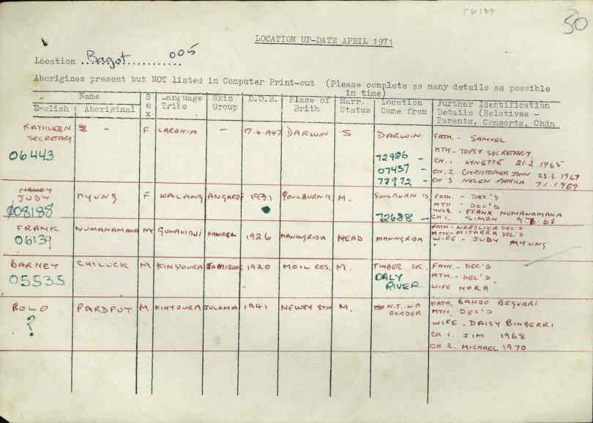

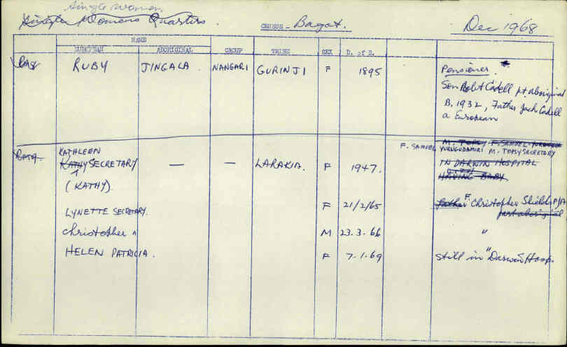
Welfare reports from the archives: Helen Secretary’s parents are Kathleen S. and Con Castrissious.
Kathleen Secretary’s parents are Topsy Secretary and Samuel Yurugudamiri (Tiwi Tribe).

